- IOD for UC01: Create a Personal Checking Account
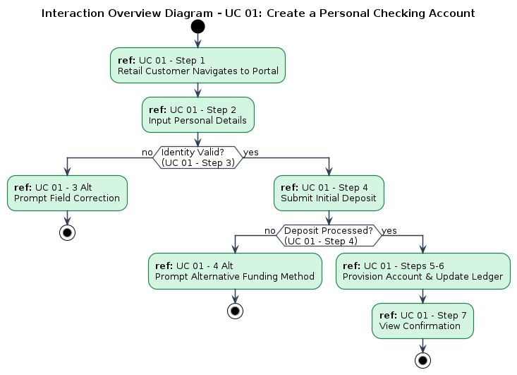
Made by: Erald Saraci
2. IOD for UC02: Initiate Bulk Payroll Processing

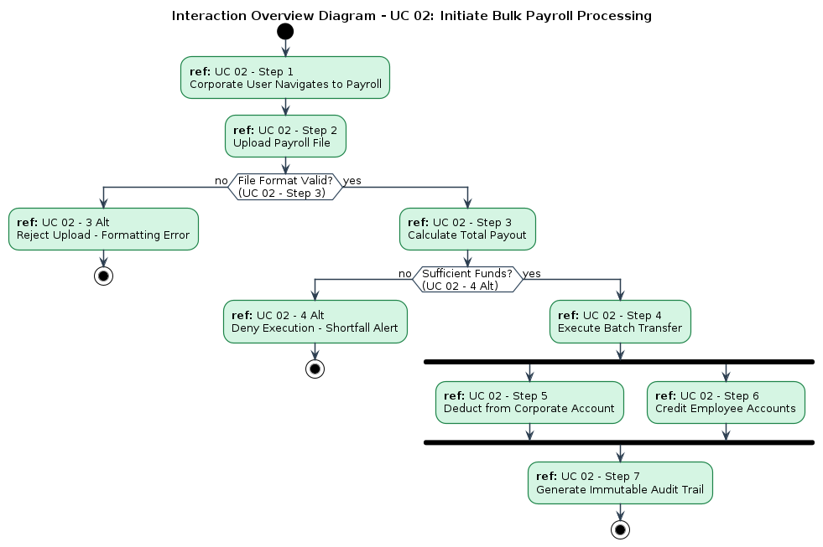
Made by: Denis Robi
3. IOD for UC06 & 07: Process Cash with Override

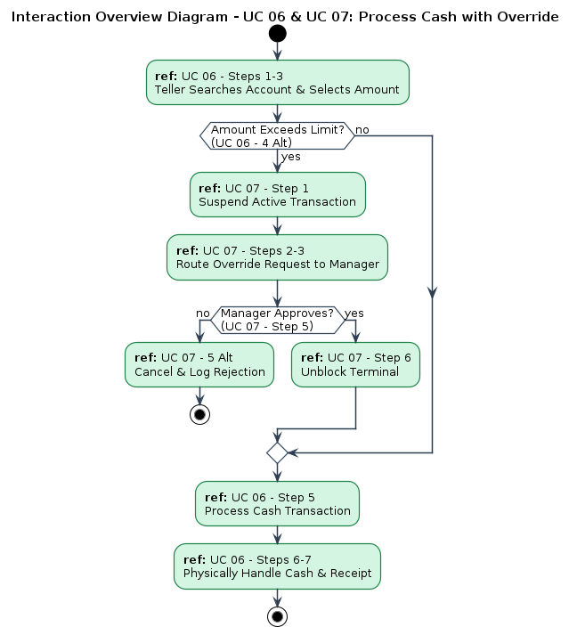
Made by: Aksel Luarasi

